Conversion of Sign Language into Text

# Mahesh Kumar N B1

*1Assistant Professor (Senior Grade), Bannari Amman Institute of Technology, Sathyamangalam, Erode, India.*

# Abstract

Sign Language Recognition is one of the most growing fields of research area. Many new techniques have been developed recently in this area. The Sign Language is mainly used for communication of deaf-dumb people. This paper shows the sign language recognizing of 26 hand gestures in Indian sign language using MATLAB. The proposed system contains four modules such as: pre-processing and hand segmentation, feature extraction, sign recognition and sign to text. By using image processing the segmentation can be done. Some of the features are extracted such as Eigen values and Eigen vectors which are used in recognition. The Linear Discriminant Analysis (LDA) algorithm was used for gesture recognition and recognized gesture is converted into text and voice format. The proposed system helps to dimensionality reduction.

**Keywords:** Hand Gesture Recognition - Human Computer Interaction - Euclidean Distance (E.D) - Eigen Values - Eigen Vectors.

# INTRODUCTION

Sign Language is the most natural and expressive way for the hearing impaired people. People, who are not deaf, never try to learn the sign language for interacting with the deaf people. This leads to isolation of the deaf people. But if the computer can be programmed in such a way that it can translate sign language to text format, the difference between the normal people and the deaf community can be minimized. Indian sign language (ISL) uses both hands to represent each alphabet and gesture. ISL alphabets are derived from British Sign Language (BSL) and French Sign Language (FSL). Most of the researchers in this area concentrate on the recognition of American Sign Language (ASL) since most of the signs in ASL are single handed and thus, complexity is less. Another attractive feature is that ASL already has a standard database that is available for use. When compared with ASL, Indian Sign Language relies on both hands and thus, an ISL recognition system is more complex. A few research works carried out by the researchers in the recognition of ISL. Currently, more researchers have started doing research in ISL. Here this proposed system is able to recognize the various alphabets of Indian Sign Language; this will reduce the noise and give accurate result.

The important research problem in computer recognition is the sign language for enabling communication with hearing impaired people. This system introduces efficient and fast techniques for identification of the hand gesture representing

an alphabet of the Sign Language. Currently, more interest is created to do research in the field of sign language recognition system.

Deaf and Dumb people rely on sign language interpreters for communications. A real time Sign Language Recognition system was designed and implemented to recognize 26 gestures from the Indian Sign Language by hand gesture recognition system for text generation. The signs are captured by using web cam. This signs are processed for feature extraction using some colour model. The extracted features are compared by using pattern matching algorithm. In order to calculate the sign recognition, the features are compared with testing database. Finally, recognized gesture is converted into text. This system provides an opportunity for a deaf-dumb people to communicate with non-signing people without the need of an interpreter.

In the existing systems, BSL uses a two-handed finger- spelling system, compared to the one-handed system used in ASL (and FSL). Many American Deaf believe that one- handed finger-spelling makes for faster finger-spelling than two-handed systems. However, anecdotal evidence has it that in a challenge between proficient ASL and BSL speakers, neither finger-spelling system proved to be faster; both finished reciting the alphabet at the same time. So that supposed “disadvantage” is rendered invalid.

According to many Europeans, American signers tend to fingerspell “too much” compared to the rate of finger-spelling in many European sign languages, including BSL. This may be true; several examples of BSL signs for concepts that do not have a sign in ASL and are often finger-spelled for lack of a formal sign. This is one of the advantages of BSL, but that is not intrinsic to the language itself and it reveals a cultural value. On the other hand, that many BSL signs are often derived from their initialized (English) base, while many ASL signs have been developed without initialization ( including the influence of signed English systems ), so one might see that as a “disadvantage “.

Nowadays, people are not interested to speak in ASL when having a deaf relative or friend, or even classmate/acquaintance. Hence, deaf people are often trapped and isolated. ASL requires the use of a person’s hands so if something happens where a wrist was sprained and it disables that person from talking. For example, there was a mother who strained her wrist from signing all of her life for her deaf daughter. The doctor also made her stop signing. This caused the communication with her deaf daughter to decrease, since she had to read lips from then on.

ASL vocabulary dictionary contains thousands of sign just

like words. It is very easy to get two completely different signs mixed up which leads to bad miscommunication. For example, the sign for “chocolate” and “cleve land” are similar, and they definitely don’t mean the same thing, or even close. It is very hard to follow when a conversation has and something gets mixed up.

# RELATED WORKS

A various hand gestures were recognized with different methods by different researchers in which were implemented in different fields. The recognition of various hand gestures were done by vision based approaches, data glove based approaches, soft computing approaches like Artificial Neural Network, Fuzzy logic, Genetic Algorithm and others like PCA, Canonical Analysis, etc. The recognition techniques are divided into three broad categories such as Hand segmentation approaches, Feature extraction approaches and Gesture recognition approaches.

“Application research on face detection technology uses Open CV technology in mobile augmented reality” introduces the typical technology. Open source computer vision library, Open CV for short is a cross-platform library computer vision based on open source distribution. The Open CV, with C language provides a very rich visual processing algorithm to write it part and combined with the characteristics of its open source. Data gloves and Vision based method are commonly used to interpret gestures for human computer interaction. The sensors attached to a glove that finger flexion into electrical signals for determining the hand posture in the data gloves method. The camera is used to capture the image gestures in the vision based method. The vision based method reduces the difficulties as in the glove based method.

“Hand talk-a sign language recognition based on accelerometer and semi data” this paper introduces American Sign Language conventions. It is part of the “deaf culture” and includes its own system of puns, inside jokes, etc. It is very difficult to understand understanding someone speaking Japanese by English speaker. The sign language of Sweden is very difficult to understand by the speaker of ASL. ASL consists of approximately 6000 gestures of common words with spelling using finger used to communicate obscure words or proper nouns.

“Hand gesture recognition and voice conversion system for dumb people” proposed lower the communication gap between the mute community and additionally the standard world. The projected methodology interprets language into speech. The system overcomes the necessary time difficulties of dumb people and improves their manner. Compared with existing system the projected arrangement is simple as well as compact and is possible to carry to any places. This system converts the language in associate text into voice that's well explicable by blind and ancient people. The language interprets into some text kind displayed on the digital display screen, to facilitate the deaf people likewise. In world applications, this system is helpful for deaf and dumb of us those cannot communicate with ancient person.

Conversion of RGB to gray scale and gray scale to binary

conversion introduced in the intelligent sign language recognition using image processing. Basically any colour image is a combination of red, green, blue colour. A computer vision system is implemented to select whether to differentiate objects using colour or black and white and, if colour, to decide what colour space to use (red, green, blue or hue, saturation, luminosity).

# METHODOLOGY

**Sign Language Recognition System**

Sign language recognition is an important application of gesture recognition. Sign language recognition has two different approaches.

* Glove based approaches
* Vision based approaches.

# Glove based approaches

In this category requires signers to wear a sensor glove or a colored glove. The task will be simplified during segmentation process by wearing glove. The drawback of this approach is that the signer has to wear the sensor hardware along with the glove during the operation of the system.

# Vision based approaches

Image processing algorithms are used in Vision based technique to detect and track hand signs and facial expressions of the signer. This technique is easier to the signer since there is no need to wear any extra hardware. However, there are accuracy problems related to image processing algorithms and these problems are yet to be modified.

There are again two different approaches in vision based sign language recognition:

-3D model based

-Appearance based

3D model based methods make use of 3D information of key elements of the body parts. Using this information, several important parameters, like palm position, joint angles etc., can be obtained. This approach uses volumetric or skeletal models, or a combination of the two. Volumetric method is better suited for computer animation industry and computer vision. This approach is very computational intensive and also, systems for live analysis are still to be developed.

Appearance-based systems use images as inputs. They directly interpret from these videos/images. They don’t use a spatial representation of the body. The parameters are derived directly from the images or videos using a template database. Some templates are the deformable 2D templates of the human parts of the body, particularly hands. The sets of points on the outline of an object called as deformable templates. It is used as interpolation nodes for the objects outline approximation.

Figure 1 explains about the sign language of 26 gestures.

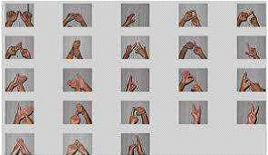

**Figure 1.** Gestures of sign recognition

# LDA ALGORITHM

The Generalization of the Fisher's linear discriminant(FLD) is known as Linear discriminant analysis (LDA). LDA mainly used in statistics, pattern recognition and machine learning. It is used to find a linear combination of features that characterizes or separates two or more classes of objects or events. The LDA and FLD are used linear classifier. Its combination also used for dimensionality reduction before later classification.

LDA is also closely resembles to principal component analysis (PCA) and factor analysis. Both PCA and factor analysis is linear combinations of variables and they describe the data in a better manner. LDA explains to model the difference between the classes of data. PCA cannot consider the difference in class but factor analysis builds the feature combinations based on differences rather than similarities. There is a difference between Discriminant analysis and factor analysis in that it is not an interdependence technique: a distinction between independent variables and dependent variables (also called criterion variables) must be made. In LDA, the measurements made on independent variables for each observation are continuous quantities. Discriminant correspondence analysis is used to deal with categorical independent variables in LDA.

# LDA APPROACH

The below figure 2 explains about the LDA approach.

1. Compute the d-dimensional mean vectors for the different classes from the dataset.
2. Compute the scatter matrices (between class and within-class scatter matrix).
3. Compute the eigenvectors (e1, e2, …., ed) and corresponding eigenvalues (λ1, λ2, ..., λd) for the scatter matrices.

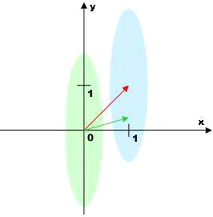

**Figure 2.** LDA approach

1. Sort the eigenvectors by decreasing Eigen values and choose k eigenvectors with the largest Eigen values to form a d×k-dimensional matrix W (where every column represents an eigenvector).
2. Use this d×k eigenvector matrix to transform the samples onto the new subspace. This can be summarized by the equation Y = X × W (where X is an n×d-dimensional matrix; the ith row represents the ith sample, and Y is the transformed n×k-dimensional matrix with the n samples projected into the new subspace).

A simple block diagram of a sign language recognition system is shown in Figure 3. These images are stored in a database. The database can be either created by the researcher himself or an available database can be used. The classification of signs can be performed by using hand gestures only in Most of the sign language recognition systems. Sign language recognition consists of four steps. They are data acquisition, pre-processing, feature extraction, and sign recognition.

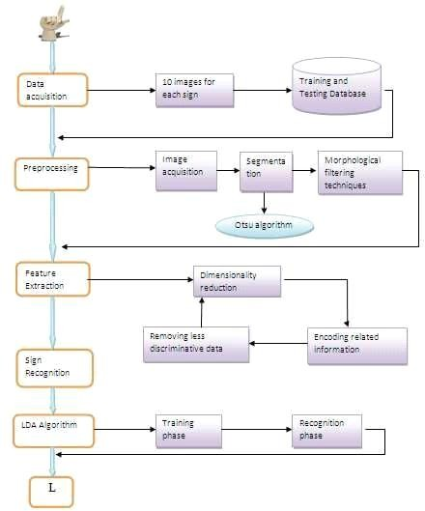

**Figure 3.** System Overview of Indian Sign Language Recognition System

The above diagram explains the following process.

# DATA ACQUISTION

To achieve a high accuracy for sign recognition in sign language recognition system, 10 images will be taken for each 26 signs. These images are included in training and testing database. The captured image at a distance is adjusted by the signer to get the required image clarity.

# PRE-PROCESSING

Pre-processing consist image acquisition, segmentation and morphological filtering methods.

# Image acquisition

This is the first step of pre-processing. This is the process of sensing of an image. So in an image acquisition, image is sensed by “illumination”. It will also involve pre-processing such as scaling. In image acquisition the image will be taken from database.

# Segmentation

Segmentation is the process in which image is converted into small segments so that the more accurate image attribute can be extracted. If the segments are properly autonomous (two segments of an image should not have any identical information) then representation and description of image will be accurate and while taking rugged segmentation, the result will not be accurate. Here the Segmentation of hands is carried out to separate object and the background. Otsu algorithm is used for segmentation purpose. The segmented hand image is represented certain features. The following figure 4 shows the segmented of hand image.

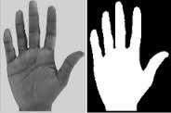

**Figure 4.** Segmented image

# MORPHOLOGICAL FILTERING

The image components are extracted by Morphological Filtering tools which are useful for representation and description of shape. Definitely the output of this process is image attribute. The following figure 5 shows the filtered form of segmented image.

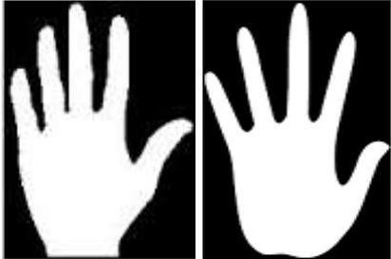

**Figure 5.** Morphological filtered image

The features extracted from the segmentation operation used for gesture recognition. The smooth contour is obtained by removing the noise from the images with Morphological filtering techniques. The pre-processing operation is done on the stored database.

# Dilation and Erosion

Dilation and Erosion are mostly used for binary images (pixels have values of 1 or 0 only).A structuring element is said to fit at a location in a binary image if all the image pixels that overlap the structuring element have value 1. A structuring element is said to hit at an image location if any of the pixels overlapping the structuring element are 1.

Binary erosion of an image f(x,y) by a structuring element s(x,y) is defined by

f *s={ 1 if s fits f, 0 otherwise

The effect of erosion is to shrink objects: pixels are removed from the boundary of the object to a depth approximating half of the structuring element’s width. Objects of this characteristic size are removed completely.

Binary dilation is similarly defined as f+s= {1 if s hits f , 0 otherwise

Its effect is to increase the size of an object by adding pixels to a depth of about half the structuring element’s width. Gaps of this size in the object are filled. The definitions can be modified for greyscale images. Rather than setting the output to zero or one, the minimum or maximum of the set of values selected by the structuring element are selected. So greyscale erosion is defined as

f *s=min {f (m- j, n- k )- s( j- k )}

And greyscale dilation as

f +s=max {f (m- j, n- k )- s( j- k )}

Structuring elements differ according to whether the image to be manipulated is binary (a flat se) or greyscale (a non-flat se). The basic syntax for creating a structuring element is

se = strel(shape, parameters);

Non-flat structuring elements are created by passing strel two matrices, the first defines the neighbourhood, the second the height at each point in the neighbourhood. In MATLAB, erosion and dilation of both binary and greyscale images are achieved by:

dst = imerode(src, se); dst = imdilate(src, se);

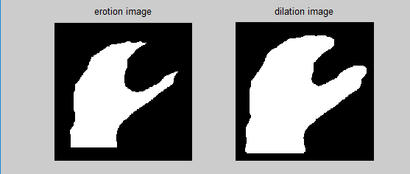

**Figure 6.** Erosion and dilation

# FEATURE EXTRACTION

The reduction of data dimensionality by encoding related information in a compressed representation and removing less discriminative data is called as Feature extraction Technique. Feature extraction is vital to gesture recognition performance. Therefore, the selection of which features to deal with and the extraction method are probably the most significant design decisions in hand motion and gesture recognition development. Here principal component is used as main features. The following figure 7 explains the feature extraction method.

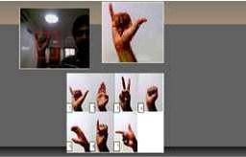

**Figure 7.** Feature extraction method

# SIGN RECOGNITION

Sign recognition using LDA is a dimensionality reduction technique based on extracting the desired number of principal components of the multi-dimensional data. The gesture recognition using LDA algorithm that involves two phases

* Training Phase
* Recognition Phase

The following figure 8 shows the dimensionality reduction technique.

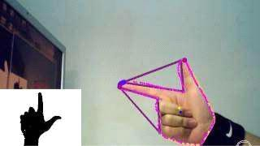

**Figure 8.** Dimensionality reduction

Each gesture is represented as a column vector in the training phase. These gesture vectors are then normalized with respect to average gesture. Next, the algorithm finds the eigenvectors of the covariance matrix of normalized gestures by using a speed up technique that reduces the number of multiplications to be performed. The corresponding gesture space projections were obtained by the eigenvector matrix then multiplied by each of the gesture vectors.

In the recognition phase, a subject gesture is normalized with respect to the average gesture and then projected onto gesture space using the eigenvector matrix. Lastly, Euclidean distance is computed between this projection and all known projections. The minimum value of these comparisons is selected for recognition during the training phase. Finally, recognized sign is converted into appropriate text and voice which is displayed on GUI.

# EXPERIMENTAL RESULTS

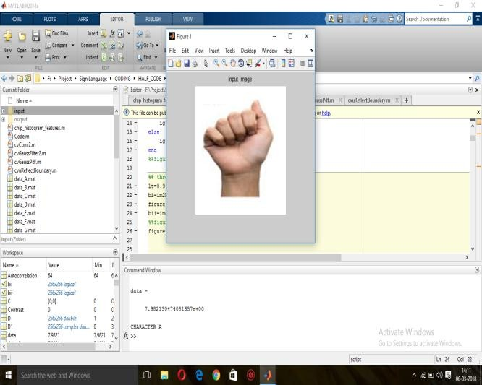

**Figure 9.** Input Image

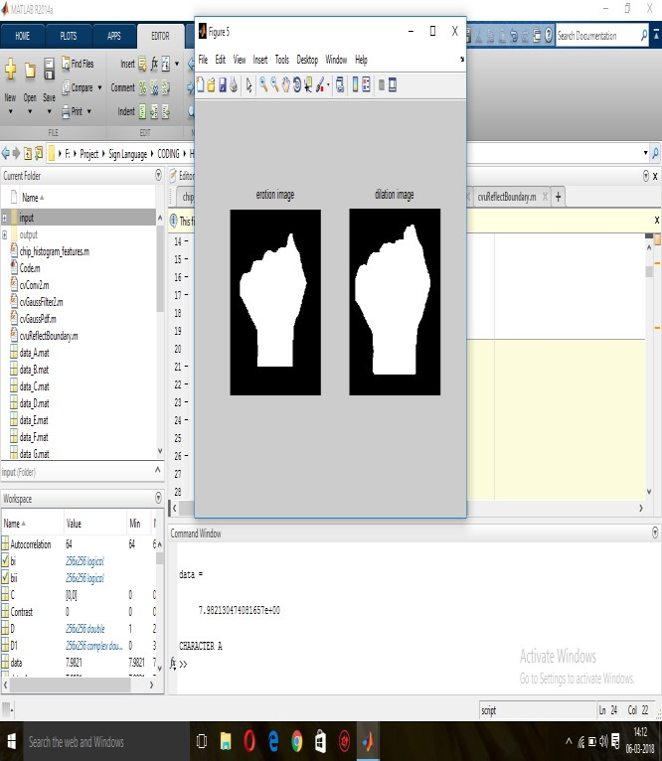

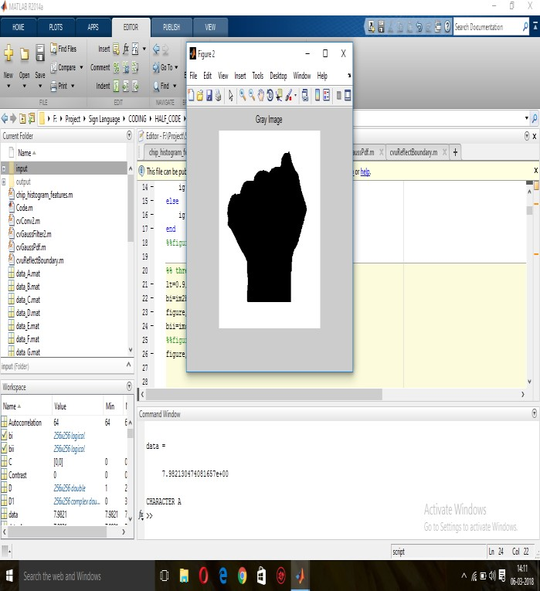**Figure 10.** Gray Image

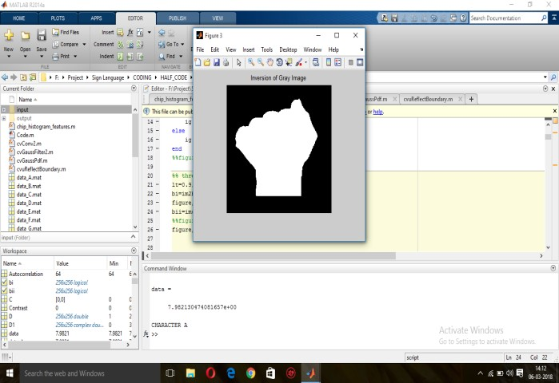

**Figure 11.** Inversion of Gray Image

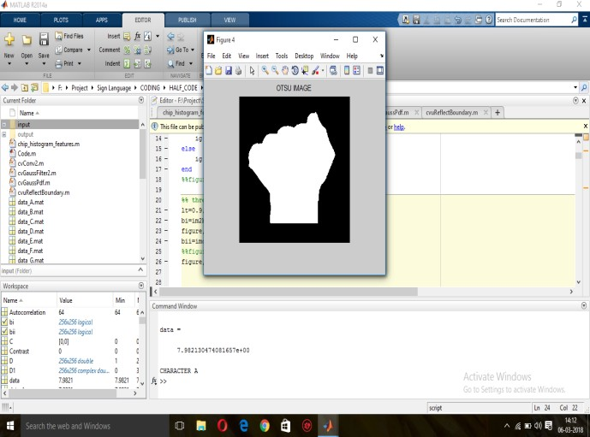

**Figure 12.** Otsu Image

**Figure 13.** Erosion and Dilation Image

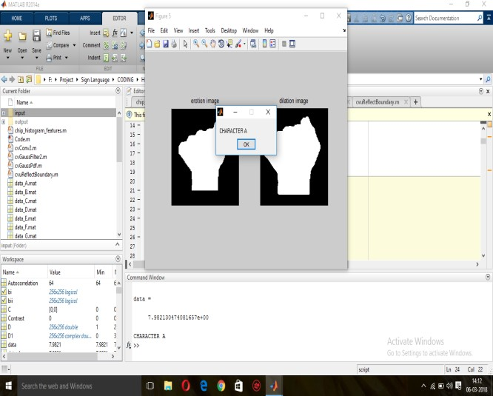

**Figure 14.** Output Image

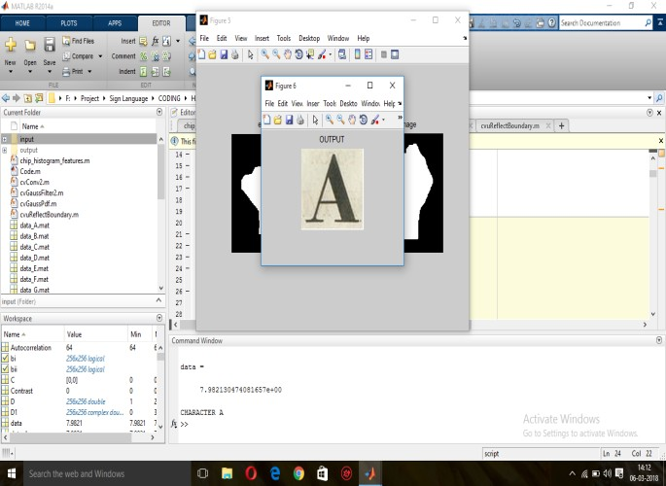

**Figure 15.** Output Image

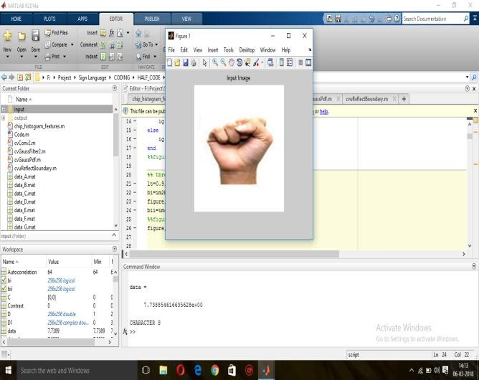 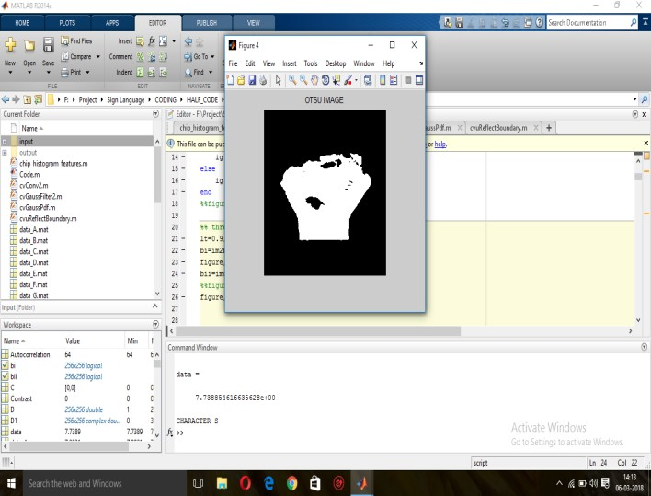

**Figure 16.** Input Image

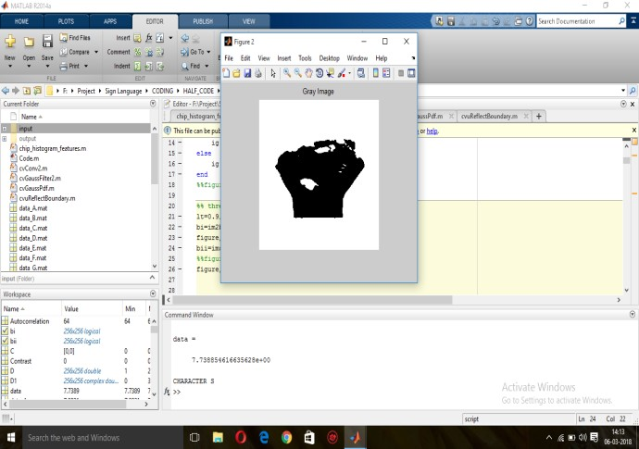

**Figure 17.** Gray Image

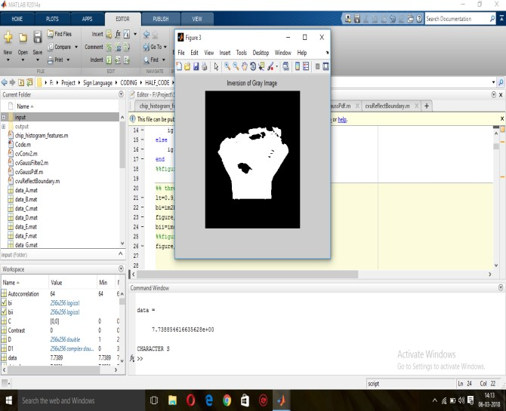

**Figure 18.** Inversion of Gray Image

**Figure 19.** Otsu Image

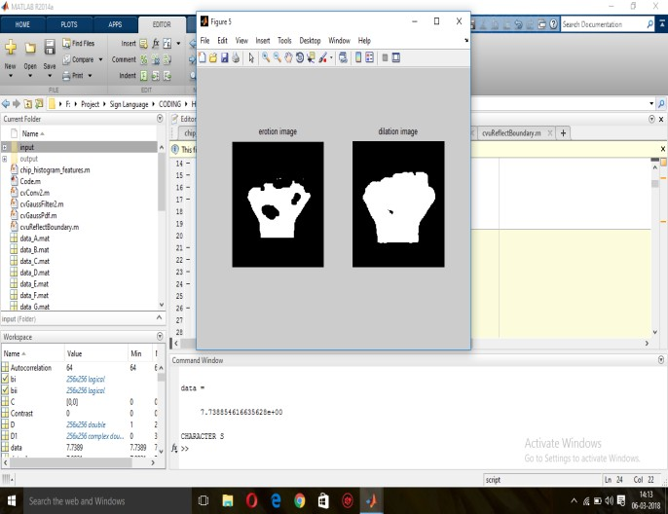

**Figure 20.** Erosion and Dilation Image

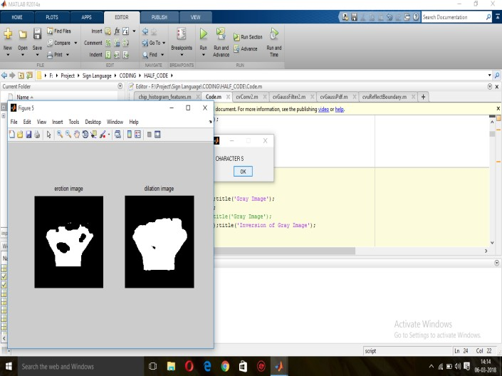

**Figure 21.** Output Image

# CONCLUSION

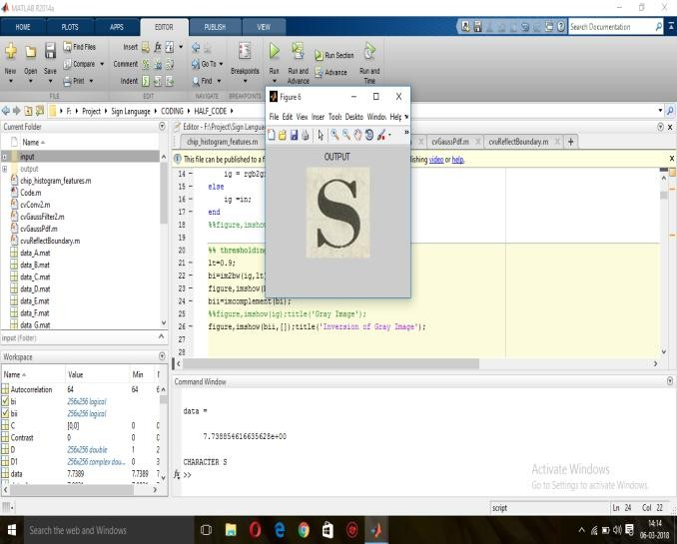**Figure 22.** Output Image

Sciences & Computing (TISC2011) , pp. 30-35, (2011).

1. Meenakshi Panwar, “Hand Gesture Recognition based on Shape Parameters” International Conference on Computing, Communication and Application (ICCCA), pp: I-6, IEEE, (2012).
2. Pravin R Futane, Rajiv V Dharaskar, “Hasta Mudra an interpretatoin of Indian sign hand gestures”, IEEE 3rd International Conference on Electronics Computer Technology, Vol.2, pp:377-380, (2011).
3. Prof. Rajeshri Rahul Itkarkar, “A Study of Vision Based Hand Gesture Recognition for Human Machine Interaction”, International Journal of Innovative Research in Advanced Engineering, Vol. 1, pp:12, (2014).
4. Rajam, P. Subha and Dr G Bala krishnan, "Real Time Indian Sign Language Recognition System to aid Deaf and Dumb people", 13thInternational Conference on Communication Technology

Currently, research works have focused mainly on the recognition of static signs of ISL from images or video sequences that have been recorded under controlled conditions. By using LDA algorithm for sign recognition operation the dimensionality will be reduced. Due to dimensionality reduction the noise will be reduced and with high accuracy. In future this project will be enhanced by determining the numbers which will be shown in words.

Using various concepts of image processing and fundamental properties of image we tried to developed this system. By using LDA algorithms recognition of gesture has done successfully. Every God creature has an importance in the society, remembering this fact, let us try to include hearing impaired people in our day to day life and live together.

# REFERENCES

* 1. Anuja V.Nair, Bindu.V, “A Review on Indian Sign Language Recognition”, International journal of computer applications, Vol. 73, pp: 22, (2013).
  2. Archana S. Ghotkar, Rucha Khatal, Sanjana Khupase, Surbhi Asati & Mithila Hadap, “Hand Gesture Recognition for Indian Sign Language”, IEEE International Conference on Computer Communication and Informatics (lCCCI ), pp: 1-4, (2012).
  3. Hu Peng, “Application Research on Face Detection Technology based on Open CV in Mobile Augmented Reality”, International Journal of Signal Processing, Image Processing and Pattern Recognition, Vol. 8, No. 2 (2015).
  4. J. Rekha, J. Bhattacharya, and S. Majumder, “Shape, Texture and Local Movement Hand Gesture Features for Indian Sign Language Recognition”, IEEE 3rd International Conference on Trendz in Information

(ICCT),pp. 737-742, (2011).

1. Ruize Xu, Shengli Zhou, Li, W.J, “MEMS Accelerometer Based Nonspecific-User Hand Gesture Recognition”, IEEE Sensors Journal, vol.12, no.5, pp.1166-1173, (2012).
2. K. Tokuda, H. Zen, A.W. Black, “An HMM-based speech synthesis system applied to English”, Proc. of 2002 IEEE Speech Synthesis Workshop, pp 227-230, (2002).
3. Tokuda, K.; Nankaku, Y.; Toda, T.; Zen, H.; Yamagishi, J.; Oura, K., “Speech Synthesis Based on Hidden Markov Models”, in Proceedings of the IEEE, vol.101, no.5, pp.1234-1252, (2013).